Obstacle Detection Using Image Processing Techniques
Omar Mones∗, Amr Sayed∗,
Zakaria Shamseldin Eleila∗, Karim Hassan Ali ∗, Mohammed Hany ∗ and AbdElRahman Mahmoud Refaat Gad∗
∗German University in Cairo (GUC), Egypt
Emails: omar.hendawy@student.guc.edu.eg, amr.behery@student.guc.edu.eg, zakaria.eleila@student.guc.edu.eg,
Karim.ali@student.guc.edu.eg, mohammed.hany@student.guc.edu.eg, abdelrahman.gad@student.guc.edu.eg

I. INTRODUCTION
Autonomous vehicles have attracted significant attention over the past two decades, with extensive research devoted to addressing the many challenges facing the autonomous driving industry. Among these challenges, perception remains one of the most critical, as it concerns how a vehicle interprets and understands its surrounding environment. A key aspect of perception is obstacle detection.
This project aims to design and implement a computer vision system using a Raspberry Pi 5 and a 5 MP camera module to detect a colored cube representing an obstacle with dimensions of 10 × 10 cm. The system will employ image processing techniques to identify the cube based on its color and geometric features. In addition to detection, the system will estimate the cube’s position within the image frame and approximate its distance from the camera. The ultimate objective is to develop a reliable real-time detection framework that can later be integrated with robotic control or autonomous navigation systems.
This paper is divided as follows: Section II shows previous literature on this topic, section III shows the used hardware system and the circuit diagram, section IV shows the simulations done on the system and comparing it to real life testing and section V shows the concluding thoughts on the results of the project.

II. LITERATURE REVIEW
The topic of obstacle detection using image processing techniques has been tackled by different papers. In [1], lanes, street signs and obstacles were detected using a multistage pre-processing technique. The images were then further processed where Canny edge detection and Hough transform techniques were used to detect the required objects. In [2], a Water Obstacle Detection network based on Image Segmentation (WODIS) was developed where it utilized an encoder network, an Attention Refine Module (ARM) and a Feature Fusion Module (FFM). In [3], a depth camera is used for omni-directional obstacle detection. A method applying region growth for depth image and a fast inpainting method for depth image was proposed to extract and repair the obstacle regions in the depth images. After that, an improved method of iterative normalized cut was used to cluster and segment fragmentary and irregular obstacle regions to generate the complete obstacle regions which are viewed using a three-dimensional visualization method. In [4], a reconstruction module that can be used with many existing semantic segmentation networks and that is trained to recognize and reconstruct the drivable surface from a small bottleneck was proposed where any poor reconstruction of the road surface was attributed to the existence of obstacles in the vehicle’s way. In [5], two different optimization techniques (Ant Colony Optimization (ACO) and Bee Colony Optimization (BCO) algorithms) were used for edge identification to help in obstacle detection.

III. HARDWARE DESIGN AND IMPLEMENTATION
In this section, the hardware components, in addition to the circuit diagram are going to be shown.

A. Vehicle Assembly
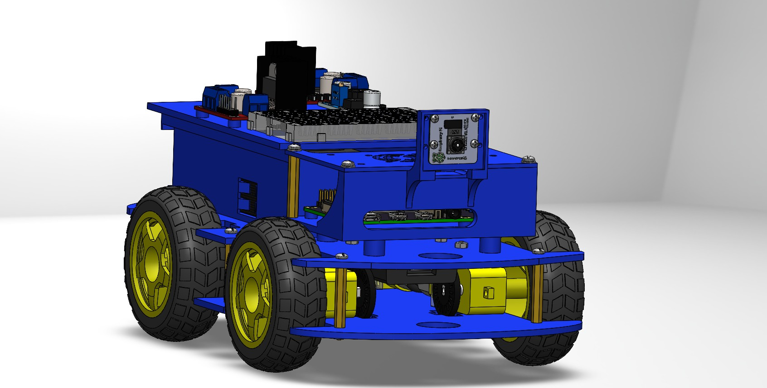
Figure 1: Solidworks Design

B. Hardware Components
Table I shows the components used to build the used vehicle.

C. Circuit Diagram
Figure 2 shows the circuit diagram used in our vehicle.

IV. System Explanation + Simulation Results:
The Implemented System is a vision-based motor control platform that uses a Raspberry pi camera and image
processing techniques that detects the cube (object) and control the motor based on the distance between the cube and the camera. The system combines combines computer vision algorithms , serial communications, and real-time video streaming. The image captured by the camera are processed using OpenCV to identify the cube, estimate it’s distance, and determine the corresponding motor commands. The program continuously analyzes the camera feed, performs object detection and calculates distance
of the cube, and sends commands to the motor controller (raspberry-pi 5) via serial interface. Additionally, the Flask web server is used to display the camera’s live feed along with the detection results. The Image is first captured then is converted to Grayscale image. A Gaussian Blur Filter is applied to reduce high-frequency noise and smooth the image which improves the stability of the subsequent segmentation operations. The Histogram Equalizations techniques are applied on the image to allow contrast enhancement which in response enhances the robustness of the object detection process under different lightening conditions. There is a Background subtraction technique meaning (the difference between the current frame and the background ). Also, a foreground mask detection identifies regions where motion or object presence is detected and all this requires morphological operations to refine the mask which in return improves segmentation quality and reduces false detections. Another plus, The cube is detected through color segmentation in the HSV( separates color information from intensity) color space. Then, the feature extraction and object validation is applied using several geometric features to determine whether it corresponds to the cube.

The Raspberry pi is a compact embedded computing platform designed for low power consumption and portability. However, due to compared to a desktop computer, its speed is generally lower when executing computationally intensive tasks such as image processing. In contrast, a computer typically contains a higher performance processer and a greater memory resource, which allows it to process image frames significantly faster.
Even through the relationship between FPS and frame time FPS= 1/Time frame , so the laptop performance will have higher FPS (50-120) Compared to Raspberry pi 5 (8-20) so the laptop is much faster and also have higher processing time and pipelining and better outcome even in efficiency.

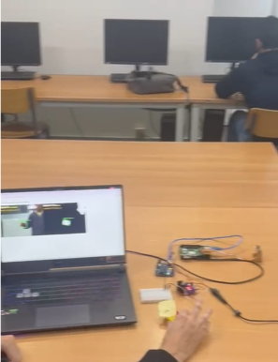
Image A: Cube Detection for distance less than 20cm and speed=160rpm

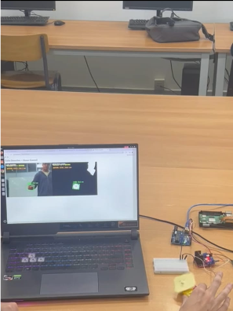

Image B: A Cube Detection for distance:20-30cm speed=0rpm

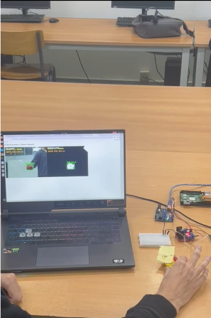

Image C: A Cube Detection for distance: 30cm speed=160 rpm

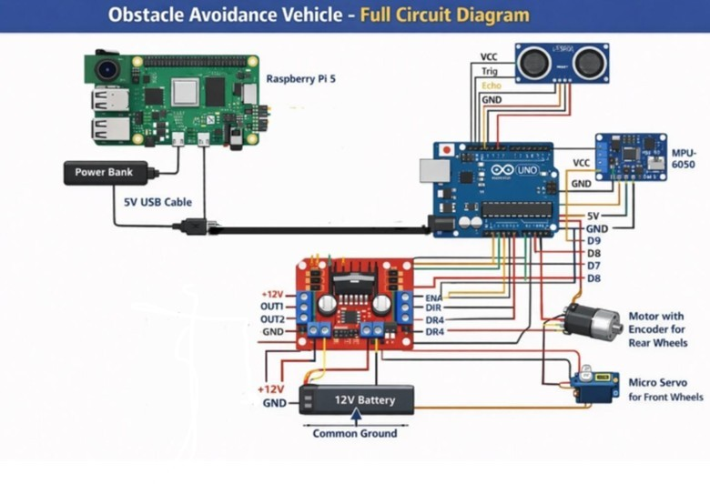

Component | Quantity | Price(EGP) | Where to buy
Raspberry PI 5 Model B 8GB | 1 | 6300 | Most Electronics
Power Bank | 1 | 2800 | Xiaomistore
Micro-Servo Motor | 1 | 90 | Makers Electronics
DC Gear Motor With Encoder | 1 | 475 | Ampere Electronics
Jumper Wires | 20 or more | 50 | Future Electronics
Vehicle | 1 | 1500 | 3D-Printed
Raspberry PI Camera | 1 | 800 | Future Electronics
IMU 6050 Sensor | 1 | 650 | Ampere Electronics
Breadboard | 1 | 35 | Ampere Electronics
L-298 H-bridge | 1 | 70 | Ampere Electronics
Figure 2: Electric circuit diagram

Table 1: List of Components
REFERENCES
- S. Fernandes, D. Duseja, and R. Muthalagu, “Application of image processing techniques for autonomous cars,” Proceedings of Engineering and Technology Innovation, vol. 17, p. 1, 2021.
- X. Chen, Y. Liu, and K. Achuthan, “Wodis: Water obstacle detection network based on image segmentation for autonomous surface vehicles in maritime environments,” IEEE Transactions on Instrumentation and Measurement, vol. 70, pp. 1–13, 2021.
- X. Zhao, H. Wu, Z. Xu, and H. Min, “Omni-directional obstacle detection for vehicles based on depth camera,” IEEE Access, vol. 8, pp. 93733–93748, 2020.
- T. Vojir, T. Sipka, R. Aljundi, N. Chumerin, D. O. Reino,ˇ and J. Matas, “Road anomaly detection by partial image reconstruction with segmentation coupling,” in Proceedings of the IEEE/CVF international conference on computer vision, 2021, pp. 15651–15660.

- B. Hariprasanna and S. V. S. Devi, “Applying nature-inspired optimization: Ant and bee colony approaches for enhanced edge detection in image processing,” in 2025 Third International Conference on Augmented Intelligence and Sustainable Systems (ICAISS). IEEE, 2025, pp. 160–165

